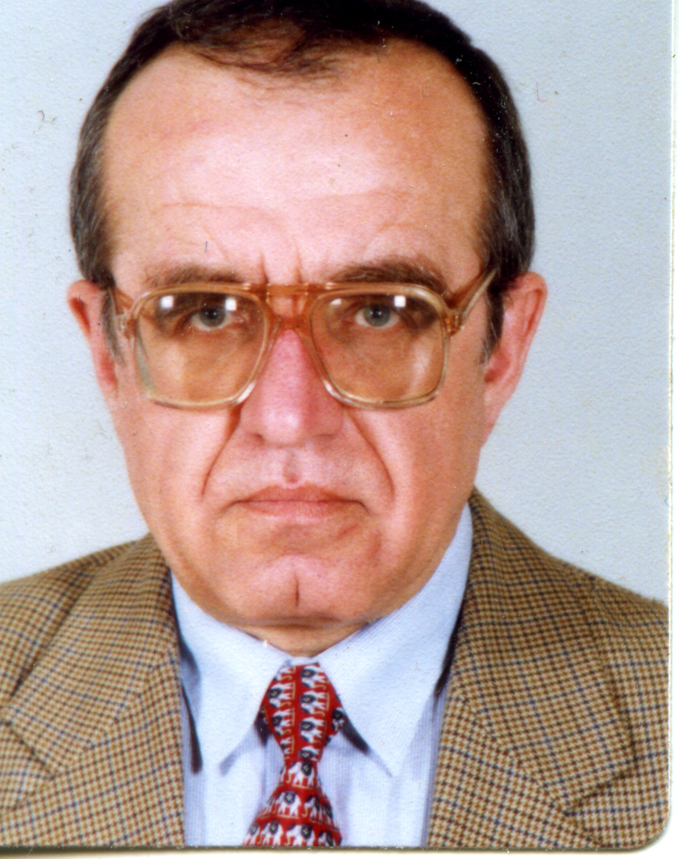 | Prof. Boris Kolev, PhD  Head of Section " Economic and Social geography"  Tel.: +359 2 979 3368  Е-mail: bkolev@bas.bg  Research interests (key words):  regional development, regional policy, geopolitics, economic geography, transcribing geographical names  Education:  1984 - Specialization in Czechoslovakia (Prague, Brno)  1983 – PhD, code 01.08.02 (Economic and Social geography) – Bulgarian Academy of Sciences - Institute of Geography  1979 - Specialization in the USSR (Moscow, Novosibirsk)  1973 – MA - St. Kliment Ohridski Sofia University, Geology and Geography Faculty - M Sc (Economic and Social Geography).  Professional experience:  2009 – present - BAS - National Institute of Geophysics, Geodesy and Geography, Professor  1994 - 2009 - BAS - Institute of Geography, Associate Professor.  1974 - 1994 - BAS - Institute of Geography, Research Fellow  Recent projects (last 5 years):  Harmonization Bulgarian national values with European values Harmonization of the Bulgarian national values with EU values: achievements and problems (a scientific consortium of the Institute of Geography, the Institute of Philosophy and the Institute if Sociology at the Bulgarian Academy of Sciences), project leader: corr. member V. Prodanov, (leader of the Institute of Geography team), 2007 – 2013  Globalization and urban development in Hungary and Bulgaria, Project leader: prof. Chavdar Mladenov, 2007 – 2009  Influence of the Danube River on the urbanization and the sustainable development of the settlements network in Hungary and Bulgaria, Project leader: prof. Chavdar Mladenov, 2007 – 2009  A Comparative analysis of the problems of sustainable development of Rhodope Mountains and Apuseni. Bilateral project with the Romanian Academy of Sciences, (Head of the Bulgarian side), 2005-2007  Transliteration of geographical names in the World Atlas, Edition of Reader's Digest, (Project leader), 2006-2009  EU INTERREG III B Project on an International GIS Laboratory of Regional Development in Thessaloniki, 2007 (National Coordinator for Bulgaria).  Strategy for an Accelerated Economic Development of Bulgaria - Report to the President of the Republic of Bulgaria, 2007  EU ESTIA Spatial Planning Priorities in Southeast Europe Project, (National Coordinator for Bulgaria), 2000-2006  Selected Publications (last 5 years):  Kolev, B., 2013. Intercontinental Straits, Hepon Press Ed. Sofia.  Kolev, B. and al., 2011. Geographical Vocabulary, Prof. M. Drinov Ed., Sofia - in print.  Kolev, B., M. Grozeva (2011). Quantitative assessment of the Danubian state border between Bulgaria and Romania. In: Acta Universitatis Palackianae – Geographica, Vol. 42, No. 1, pp. 5963. Olomouc.  Kolev, B., 2010. Geography of the Enclaves, Hepon Press Ed. Sofia.  Kolev, B. and al., 2010. Bulgaria – A Geographical Atlas, Tangra Ed., Sofia.  Kolev, B., 2008. National Geographical Space of the Republic of Bulgaria, Hepon Press Ed. Sofia.  Kolev, B., 2008. National Geographical Space (NGS) of the Republic of Bulgaria, In: Earth-the Restless planet, BG Print Ed., Vratsa.  Kolev, B. and al., 2007. Strategy for an Accelerated Economic Development of Bulgaria - Report to the President of the Republic of Bulgaria, Ed. by Institute of Economics – BAS, Sofia, pp. 94-97.  Kolev, B., M. Grozeva, 2010. Bulgarian theory and practice and EU geo-ecological values . In: BALKANI`21, 7, www.balkans21.org  Kolev, B., 2010. Significance of transport-geographical position of Bulgaria for regional cooperation in Southeastern Europe. In: Proceedings of Intl. Conference on Geography and Regional Development, Ed. by NIGGG, Sofia.  Kolev, B., 2010. Legislative framework of the Cultural and Historical heritage in Bulgaria as a basis for the development of the Cultural and Historical tourism, Problems of Geography, 1-2.  Kolev, B., 2008. Geographical Space, Problems of Geography, 1-2.  Kolev, B., M. Grozeva, 2007. Regional distribution of Some Demographic and land-use parameters in Bulgaria. In: Regionality and/or Locality, Ed. by A. Kovacs, Centre for Regional Studies, Pecs (Hungary).

