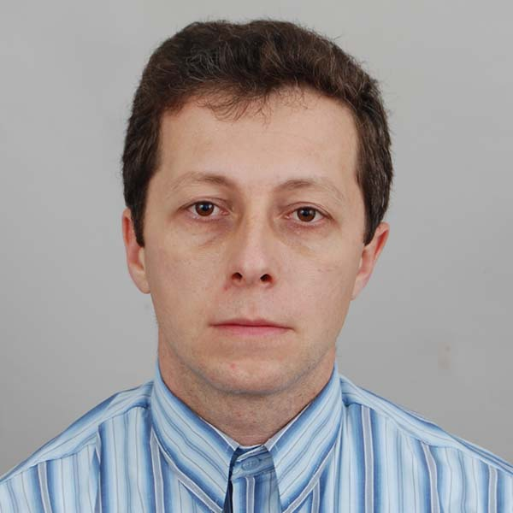 | Assoc. Prof. Georgi Zhelezov, PhD  Head of Section "Physical Geography"  Tel.: +359 2 979 3304  Е-mail: gzhelezov@abv.bg; gzhelezov@gmail.com  Research interests (key words):  Landscape ecology, wetland studies, biogeography, ecosystem services, sustainable development and sustainable use, mountain researches in southeastern Europe, cartography, GIS.  Education:  Ph.D., Cartography (Thematically cartography) , Sofia University, 2005.  MA, Landscape studies and environment protection; minor: Radio journalism, Sofia University, 1999.  Professional experience:  2010 – Assoc. Prof., Head of Section “Physical Geography” – National Institute of Geophysics, Geodesy and Geography, BAS.  2009-2010 Senior research fellow – Institute of Geography, BAS.  2005-2009 Research fellow – Institute of Geography, BAS.  Recent projects (last 5 years):  Geographic Atlas of the Republic of Bulgaria, Project Leader Assoc. Prof. Ilya Kopralev 2006-2009.  Bulgarian’s Natural and Cultural heritage. A Basis for Development of Local, Regional and Natioanal Tourist Products, Project Leader Assoc. Prof. Peter Petrov, 2005-2010.  Creation of Spatial (GIS) Data Bases for the Objects of Natural and Cultural Heritage in Danubian Plain. Project Leader Assit. Prof. Julia Kroumova, 2010-2011.  Comparative Characteristics of the Lakes Cerknitsa and Sreburna from the Point of View of the Ecosystem Services, Project Leader Assoc. Prof. Peter Petrov, 2009-2011.  Experimental Application of New Tehnologies (GIS and Internet) in Education of Geography and Economics in Secondary School, Project Leader Prof. Geogi Baltakov, 2003-2007.  Identifying the Research Basis for Sustainable Development of the Mountain Regions in Southeastern Europe. Foundation of Scientific Network for Research of the Mountain Regions in Southeastern Europe. Preparation of a Convention on the Protection and Sustainable Development of the Mountain Regions in Southeastern Europe. Bilateral project with Austrian scientific and research liaison office Sofia, Project Leader Assoc. Prof. Georgi Zhelezov, 2008-2010.  Transliteration of Geographical Names in World. Project Leader Prof. Boris Kolev, 2006-2009.  Environmental Change and Nature Protection Along the Bulgarian and Romanian Banks of the Danube River, Project Leader Assoc. Prof. Mariyana Nikolova, 2006-2008.  Environmental Status and Transformation Dynamics of the Lower Danube Wetlands Proposed for ecological Reconstruction, Project Leader Assoc. Prof. Tsvetan Kotsev, 2009-2011.  Investigation of Medical and Fruit Plants in National Park “Central Balkan” ( based on GIS), Project Leader Assit. Prof. Chavdar Gusev, 2006-2007.  Development of High qualified Young Researchers in Information Technologies for Cultivation and Management of Knowledge’s, Project Leader Assoc. Prof. Mustakerov, 2010.  Territorial Sketch for Sustainable Use and Protection of Nature Resources in Lukovit Municipality, Project Leader Prof. Peter Petrov, 2006-2007.  Sustainable Natureuse and Development of Nontraditional Touristical Forms in Nevestino Municipality, Project Leader Assoc. Prof. Peter Petrov, 2007.  Hydroecological Characteristic of Black Sea Wetland systems, Project, Leader Assoc. Prof. Neli Hristova, 2008-2010.  Development of Certification System for Sustainable Tourism, Project Leader Assoc. Prof. Zoya Mateeva, 2005-2008.  Selected Publications (last 5 years):  Zhelezov, G. /editor/ 2011. Sustainable Development in Mountain Regions. Southeastern Europe. Springer. 291.  Zhelezov, G. 2007. Nature Geography of Dobrudzha and Ludogorie. “Kovachev “ Press. Silistra. 197.  Zhelezov, G. 2011.Models and strategies for sustainable management of mountain territories in Central and Southeastern Europe. In Sustainable Development of the Mountain Regions: Southeastern Europe Springer, 273-281.  Zhelezov, G., M. Stoyneva. 2007. Hydrographic characteristics and hydrological zonation of Bulgaria. In Inventory of Bulgarian wetlands and their biodiversity, Edited by Michev, T. & M. Stoyneva. Elsi-M, Sofia, 143-145.  Zhelezov, G. 2007. Spatial modeling and analysis of the wetland system. In Inventory of Bulgarian wetlands and their biodiversity, Edited by Michev, T. & M. Stoyneva. Elsi-M, 131-137.  Zhelezov, G. 2010. Opportunities for development of alternative tourism in wetland system in Danubian zone between Rousse and Silistra. Problems of Geography, Book 1-2, Sofia, 51-58.  Zhelezov, G. 2008. Charakteristic of the eutrophication processes in Sreburna wetland system. Problems of geography, Book 3-4, Sofia, 167-174.  Zhelezov, G. 2008. Present hydroecological status of Smolyan wetland system. Problems of Geography, Book 1-2, Sofia, 114-122.  Zhelezov, G. 2008, Zoogeographical regionalization of Bulgaria, Problems of Geography, Book 3-4, Sofia, 189-197.  Hristova, N., G. Zhelezov. 2007. Hydrological picture of Ludogorie-Dobrudzha region. Years book of Sofia University, book 2, Volume 98, Sofia, 75-93.  Zhelezov, G. 2007. Characteristic and spatial modeling of landscape diversity in Ludogorie –Dobrudzha region. Problems of Geography, Book 1-2, Sofia, 47-58.  Zhelezov, G. 2007. Analysis of phytoproductivity of the landscapes in Ludogorie – Dobrudzha region. Problems of Geography, Book 1-2, Sofia, 59-69.  Hristova, N., G. Zhelezov Antropegenic transformations in Pomorie lake, Years book of Sofia University /in print/.  Zhelezov, G., A. Gaberscik, M. Vurbanov, M. Germ, Characteristic and dynamic of the waters in the lakes Sreburna and Cercnise, Problems of geography /in print/.  Zhelezov, G., Geoecological aspects of wetlands, Magazine Biology, ecology and Biotechnology/ in print/.  Zhelezov, G. 2011. Modeling of the plant transformations in Biosphere reserve “Srebarna” and related ecosystem service. Proceeding of Joint ICA Symposium. Oreleans, 274-285.  Zhelezov, G., N. Hristova. 2010. Ecological Status of wetland “Atanasovsko Lake”. Proceeding of International Conference BALWOIS 2010, Ohrid, Republic of Macedonia, 210-216.  Zhelezov, G. 2010. Evaluation of the ecosystem service in the forest formations of Biosphere Reserve “Srebarna”, Northeastern Bulgaria. Proceeding of International Landscape Ecology International Conference, Bragança, Portugal, 107-112.  Zhelezov, G. 2010. Characteristic of the present ecological status and spatial modeling of Srebarna wetland system, Northeastern Bulgaria. Proceeding of International Conference „Landscape Ecology for the Management of the Wetlands”, Ravenna, Italy, 120-126.  Zhelezov, G. 2010. Classification of the wetlands in Bulgaria, International conference “Geography and regional development”, Sofia, 2010, 428-436.  Petrov, P., G. Zhelezov, St. Genchev. 2010. Danubian recreation zone – problems and perspectives, International conference “Geography and regional development”, Sofia, 2010, 299-305.  Zhelezov, G. 2009. Status and dynamic evolution of the wetland systems in Danubian sector between Rousse and Silistra, Papers of scientific conference “NATURA 2000 in transborder region Bulgaria-Romania – problems and perspectives”, Vratsa, 31-47.  Zhelezov, G., 2009. Analysis of the Dynamic in Eutrophication Processes in Shabla Wetland System. Proceeding of International Symposium on “Modern technologies, education and professional practice in geodesy and related fields. Sofia, 81-88.  Zhelezov, G. 2008. Spatial parameters in the dynamic of the euthrophication processes in Durankulak wetland system. Proceeding of International Symposium on “Modern technologies, education and professional practice in geodesy and related fields. Sofia, 194-205.  Petrov, P., E. Gachev, G. Zhelezov. 2007. Landscapes based landuse planning in semi-mountain areas in the contexts of new economical conditions following the example of Lukovit municipality. Book of papers in conference “Global problems”, Sofia University, Sofia, 391-397.  Zhelezov, G. 2007. Modeling of the anthropogenic transformations in Brushlenska lowland, Northeastern Bulgaria. Proceeding of International Symposium on “Modern technologies, education and professional practice in geodesy and related fields. Sofia, 266-270.  Zhelezov, G. Opportunities, space and perspectives of global positional systems as a part of globalization process. 4-th conference “Globalization, eurointegration and sustainable development / in print/.  Zhelezov, G. Nature potential of Popovo region, 6-th conference “Popovo-past and future”, Popovo /in print/.  Nikolova, N., G. Zhelezov, A. Gikov, St. Nedkov. Background contamination of trace elements in soils of Strandzha’s reserves “Tisovitsa” and “Sredoka” /in print/.

