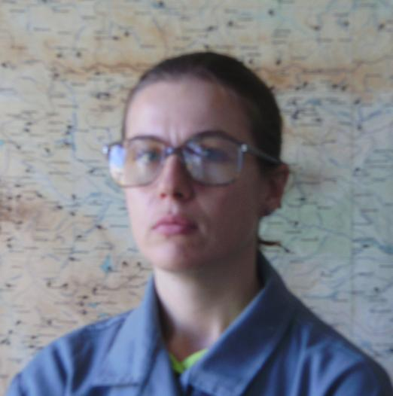 | Маriуа Теmеlkоvа  Assist. Prof.  Tel.: +3592 – 979 - 3343  Е-mail: mtniggg@gmail.com  Research interests (key words):  Hydrology, water resources management, water management balances, renewable energy sources, GIS.  Education:  1999 г. – Sofia University “St.Kliment Ohridski”– master (Hydrology).  Professional experience:  2011 – National Institute for Geophysics,Geodesy and Geography, BAS-assistant professor.  2006-2010 Institute of water problems , BAS - researcher  Recent projects (last 5 years):  Digitalizing archive of weather data base for Bulgaria, head Zoya Mateeva,2011  Water use and water management balance of the river Ogosta and the rivers in the north-west part of Bulgaria, head prof. Santurgian, 2006.  Selected Publications (last 5 years):  State and possibilities for development of renewable energy in Bulgaria- M.Varbanov, M.Temelkova, Fourth International Scientific Conference, South-West University”Neofit Rilski”, 8-11 June, Blagoevgrad, Republic of Bulgaria  Water utilization and water management balances of the Lom river basin in Bulgaria-St.Yancheva, M.Temelkova , 24 th Conference of the Danubian Countries on the hydrological forecasting and hydrological bases of water management, 2-4 June 2008 Bled, Slovenia  Water management balances assessment of a river basin water resources system in Bulgaria-St.Yancheva, M.Temelkova , A.Yordanova , 3 rd International Scientific Conference on Water Observation and Information System for Decision Support , BALWOIS 2008, 27-31 May 2008 Ohrid, Republic of Macedonia  Overview of water resources utilization and management in Bulgaria-St.Yancheva, M.Temelkova , 23 rd Conference of the Danube Countries on the hydrological forecasting and hydrological bases of water management, 28-31 August 2006 Belgrade, Republic of Serbia  Application of MODSIM software to the operation of a real Bulgarian water resources system-St.Yancheva, M.Temelkova, Conference on Water Observation and Information System for decision support 23-26 May 2006 Ohrid, Republic of Macedonia

