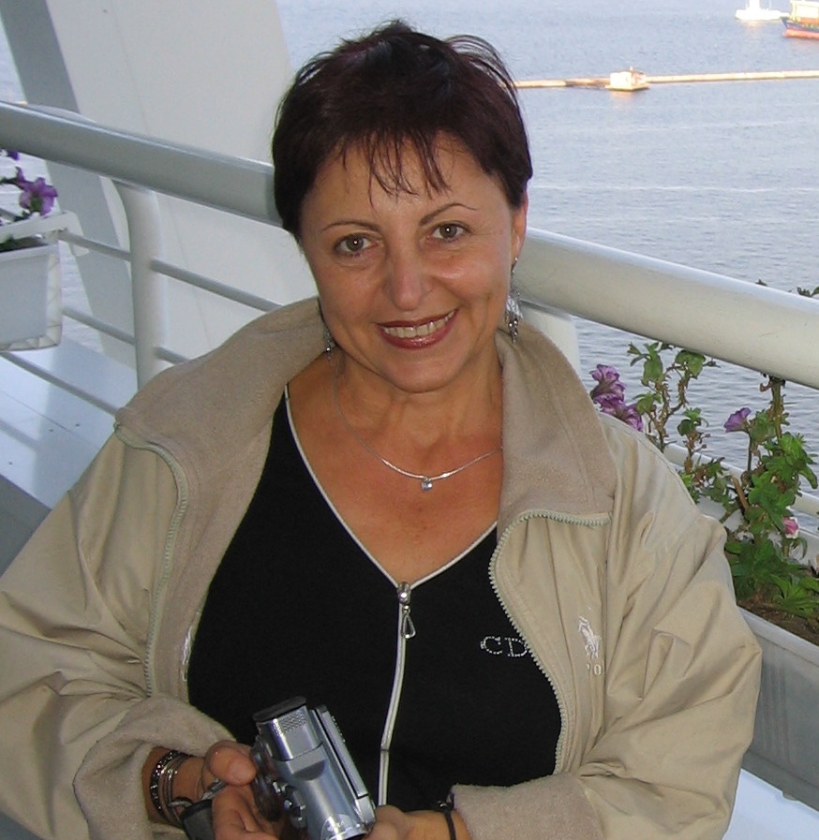 | Assoc. Prof. Zoya Mateeva, PhD  Tel.: +359 2 979 3364  Е-mail: zoyam@abv.bg  Research interests (key words):  Climatology; Bioclimatology (human); Renewable energy sources (solar & wind); Sustainable nature-usage.  Education:  1997 – Ph.D., Climatology, Institute of Geography, Bulgarian Academy of Sciences  1979 – M.Sc., Physical Geography/ Climatology, Sofia State University  Training experience:  2007 – Indicators for Sustainable Development/Tourism. Institute of Geography and Regional Policy, University of St. Gallen, Switzerland;  1997 – Bioclimatic observations. Institute of Geography and Spatial Organisation, Poland Academy of Sciences;  1988 – Bioclimatology. Institute of Geography and Spatial Organisation, Poland Academy of Sciences;  1981-1982 – Applied Climatology. Sofia State University.  Professional experience:  1999 г. – present: Assoc. Professor, National Institute of Geophysics, Geodesy and Geography at Bulgarian Academy of Sciences, Department of Geography, Section of Physical Geography  1992 – 1999: Assist. Professor I deg., Institute of Geography, Bulgarian Academy of Sciences  1989 – 1992: Assist. Professor II deg., Institute of Geography, Bulgarian Academy of Sciences  1986 – 1989: Assist. Professor III deg., Institute of Geography, Bulgarian Academy of Sciences  Recent projects (last 5 years):  2011-2014. „Development of high-resolution electronic climate-data-base for Bulgaria”. Principal Investigator. Bulgarian Academy of Sciences.  2011-2013. „Experimental climatic monitoring „NIGGG”. Principal Investigator. Bulgarian Academy of Sciences.  2011–2012. „Holistic approach for reduction of greenhouse gas emissions”. LEPED 2008/ 105851. Consultant for research&education measures. Ministry of Environment and Waters of Bulgaria.  2011. „Climatic-recreational assessment of the northern macro-slope of the mountain Rila”. Principal Investigator. “PlanEco” Ltd., Sofia.  2010-2013. „Bioclimatic parametrization of Bulgaria”. Principal Investigator. Bulgarian Academy of Sciences.  2010-2013. „Assessment of the solar-and-wind renewable energy resources of Bulgaria”. Principal Investigator. Bulgarian Academy of Sciences.  2009-2011. “Geographical Glossary of Bulgaria”. Academic Press „M.Drinov”.  2010. „A large-scale climatic expertise of wind-energy potential of Hitrino municipality”. Principal Investigator. “Wind Eco Consult” Ltd., Sofia.  2008-2010. “Geographical Atlas “Bulgaria”. Publishing house “Tangra”.  2008. „Assessment of the solar resources of Yankovo locality for the purposes of power production”. SolarPro Holding company, Sofia.  2007-2010. „Construction of solar-and-wind experimental monitoring site “Northern-Eastern Bulgaria”. Principal Investigator. Bulgarian Academy of Sciences.  2005-2008. “Development of Universal Thermal Climate Index”. “Program COST, European Science Foundation.  2007. Assessment of wind-energy resources of representative localities of Bulgaria”. „VEP 2007” Ltd, Sofia.  2007. “Wind-energy potential of the “Stana” plateou. Principal Investigator. „VEP 2007” Ltd, Sofia.  2005-2008. “Development of Certification System for Sustainable Tourism”. Principal Investigator for Bulgaria. Program SCOPES, Swiss National Science Foundation.  Selected Publications (last 5 years):  Mateeva, Z. and M. Yordanova. Transformation of sustainable tourism indicator system for certification purposes. In: Proceedings from XVI Int. Simposium “Ecology 2007”, Technomat&Infotel, 2007 (in Bulgarian).  Mateeva, Z. Human bioclimatic comfort. Parametrization of bioclimatic monitoring. Journal “International Scientific Publications: Ecology & Safety, Technomat & Infotel, 2008, ISSN 1313-2563.  Mateeva, Z., A.Filipov and V.Filipov. Construction of research wind-solar monitoring station “North-East Bulgaria”. Journal “International Scientific Publications: Ecology & Safety”, vol. IV, Technomat & Infotel, 2008.  Boesch, M., Z.Mateeva and M.Yordanova. Inquiry study on the attitudes of central authorities towards certification of sustainable tourism. Journal “International Scientific Publications: Ecology & Safety”, Technomat & Infotel, 2008, ISSN 1313-2563 (in Bulgarian).  Mateeva, Z. Climate and Tourism. Chapter from the final research report of COST-730 Action, 2009.  Mateeva, Z., A. Filipov et al. Building and Exploitation of Research Meteo-Tower for Monitoring of Wind and Solar Parameters. Journal “International Scientific Publications: Ecology & Safety”, Volume 3, Part 2, Technomat & Infotel, 2009, ISSN 1313-2563 (in Bulgarian).  Mateeva, Z., L.Enache and N.Mateeva. Bioclimatic effects on man and their assessment for the purposes of recreation and tourism. Journal “International Scientific Publications: Ecology & Safety”, Volume 3, Part 1, Technomat & Infotel, 2009, ISSN 1313-2563.  Mateeva, Z., A.Filipov et al. Topographic experiment on the wind field in the region of Voevodsko plateau. Journal Problems of Geography, book 4, 2009.  Mateeva, Z. Thermal Comfort of Man in January. In: Atlas of Bulgaria. Publishing House “Tangra-Tanakra”, Sofia, 2010.  Mateeva, Z. Thermal Comfort of Man in July. In: Atlas of Bulgaria. Publishing House “Tangra-Tanakra”, Sofia, 2010.  Mateeva, Z. UV-index in Bulgaria - January. In: Atlas of Bulgaria. Publishing House “Tangra-Tanakra”, Sofia, 2010.  Mateeva, Z. UV-index in Bulgaria - July. In: Atlas of Bulgaria. Publishing House “Tangra-Tanakra”, Sofia, 2010.  Mateeva, Z. Mean Annual wind-energy potential in Bulgaria. In: Atlas of Bulgaria. Publishing House “Tangra-Tanakra”, Sofia, 2010.  Mateeva, Z. and A. Filipov. Mean Annual solar-energy potential in Bulgaria. In: Atlas of Bulgaria. Publishing House “Tangra-Tanakra”, Sofia, 2010.  Mateeva, Z. Climatic conditions for self-clearing of atmosphere in district towns of Bulgaria. In: Atlas of Bulgaria . Publishing House “Tangra-Tanakra”, Sofia, 2010.  Mateeva, Z. Morbidity by districts of Bulgaria. In: Atlas of Bulgaria. Publishing House “Tangra-Tanakra”, Sofia, 2010.  Mateeva, Z. Climate and therapy: definitions, assessment approaches and territorial potentials. In Proceedings from the international conference “Geography and Regional Development”, Sofia, 2010.  Матеева, З. Universal index for assessment of man’s thermal comfort and possibilities for its application in the practice. In: Proceedings from the VІІІ Congress of Medical Geography , Sofia 2010.  Yordanova, M. and Z. Mateeva. The Nature Potential of Mountains in Bulgaria and its sustainable use. In Monography «Sustainable Development in Mountain Regions: Southeastern Europe» G. Zhelezov, ed. Dordrecht: Springer, 2011. ISBN: 978-94-007-0130-4.  Mateeva, Z. Personal factors of thermal comfort: long-lasting climatic experience. Proceedings from the conference dedicated to 60-year anniversary of Department of Climatology at Faculty of Geography, Warsaw University, 2010 (forthcoming) (in English).  Матеева, З. Chapter “Climate”. Monograph “Medical Geography of Bulgaria”, volume II (in press) (in Bulgarian).

