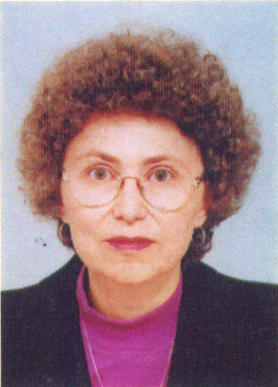 | Roumiana Dobrinova  Tel.: +3592 979 3370  Е-mail: rumi.dobrinova@abv.bg  Education:  Sofia University “St. Kliment Ohridski”:  - 1975 - Department of Geology and Geography, specialization in ‘geography’;  - 1985 - Department of Classical and Western Studies, specialization in ‘English language and literature’  Professional experience:  Translations in the field of geography

