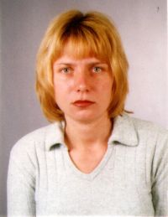 | Rositsa Mikova  PhD Student  Tel.: +3592 979 6309  Е-mail: rositzamikova@abv.bg  Research interests (key words):  Geography of Population and Settlements, migrations, urbanization.  Education:  2010 – National Institute of Geophysics, Geodesy and Geography, BAS, PhD Student in the specialty of Geography of Population and Settlements.  Master’s degree in Geography, SU "St. Kliment Ohridski"  Bachelor’s degree in Automatation of Production, College of Energy and Electronics, TU-Sofia.  Professional experience:  “Kremikovtzi”-AD, Reporter Foundation-data entry operator  Selected Publications (last 5 years):  Mikova, R. (2011) Intensity and Directions of the Inner Migrations in Bulgaria during the Period of Transition. – In: Jubilee National Scientific Conference with International Participation “The Man and the Universe”, Union of Scientists in Bulgaria-Smolyan, October 6-8, 2011 (in the press).

