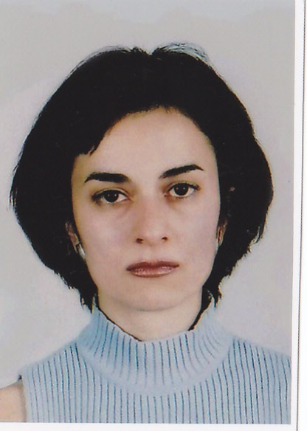 | Kristina Gartsiyanova  PhD Student  Tel.: +3592 979 3943  Е-mail: krisimar1979@gmail.com  Research interests (key words):  hydrology, hydrochemistry, quality of the river water, physical geography  Education:  2011- Bulgarian Academy of Sciences- NIGGG, PhD in quality of the river water  2005- 2007 - University of Sofia - St. “Kl. Ohridski”, Bulgaria, qualification - European public administration, master  2002- 2004 - University of Sofia – St. “Kl. Ohridski”, Bulgaria, qualification – Geography – “Hydrology and Climatology”, master  1998/99- 2001/02 - University of Sofia – St. “Kl. Ohridski”, Bulgaria, qualification - Geographer, teacher of geography, bachelor  1993- 1998 - High school for Maths and Natural sciences- Acad. “L.Chakalov” – Sofia  Professional experience:  10/2009- 09/2010 - Bulgarian Academy of Sciences, Institute of Geography- position: Geographer  12/2007- 06/2009 - “HUAWEI TECHNOLOGIES BULGARIA” LTD, position: assistant- engineering department  07/ 2004- 11/2007 - National Student House- Ministry of education, HR Department, position: assistant – coordinator  02/2003- 06/2003 - High school “K.Timiriazev”, Sofia, position: teacher of Geography  Recent projects (last 5 years):  Formation of Highly Qualified Young Researchers in Information Technologies for Optimization, Pattern Recognition and Decision Support Systems. Contract with the Ministry of Education, Youth and Science: BG051PO001-3.3.04/40/28.08.2009, Project Leader Assoc. Prof. Dr. Ivan Mustakerov, 2009-2011.  “Spatial analysis and quality evaluation of river water by hydrochemical and hydrobiological indicators”, Project Leader: Assoc. Prof. Dr. Marian Varbanov, 01.06.2010 - 31.05.2013.  Selected Publications (last 5 years):  Gartsiyanova, K. Changes of the River Water Chemical Composition and Water Quality in Uplands of the Catchment Area of River Vit and River Osam - In : proceedings from international conference “Development of economy and society based on knowledge”. St. Zagora, 2009.  Gartsiyanova, K. Nitrogenous Pollution in River Vit and River Osam - In : proceedings from international conference “Geography and regional development”. S., NIGGG-BAS, 2010, pp.503-513.  Gartsiyanova, K. Organic pollution in river Vit and river Osam. – Problems of Geography, 2011, 3-4, pp. ( in press).

