Name Surname: Evgeni Baltakov
Tel.: +359 889 109 340; +359 890 217 176; +359 876 572 687
e-mail: egb@mail.bg

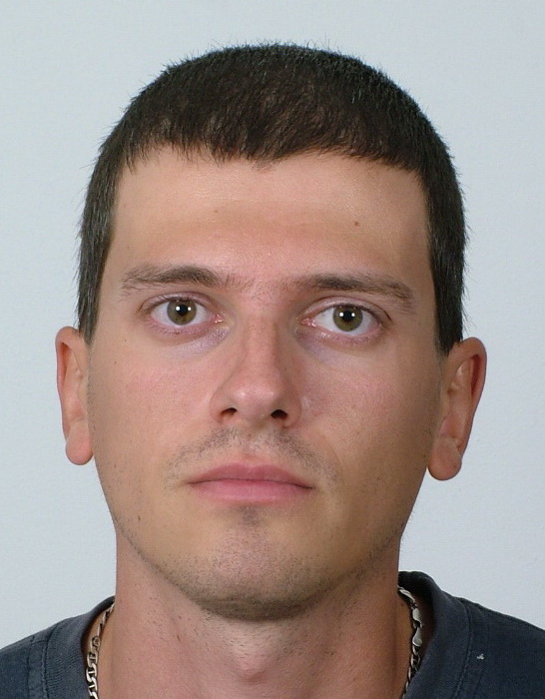

Research interest: Geomorphology, Paleogeography, karst

Background:
Education: Magister of Geomorphology

Professional experience: School teacher (27.04.2009 до 31.08.2009 г.)

Recent projects (last 5 years):
- „Working out an experimental model for complex monitoring of protected karst territories aiming at their sustainable development, management and development”, Project Leader Assoc. Prof. M. Yordanova
- “Water resources management of trance-border river basins between Republic of Bulgaria and Republic of Serbia”, Project Leader Assoc. Prof. N. Hristova
- “Development of High Qualified Young Researchers in Information Technologies for Cultivation and Management of Knowledge’s”, Project Leader Assoc. Prof. Ivan Mustakerov, 2010-2011

Selected Publications (last 5 years):

