Name Surname- Kristina Gartsiyanova
Tel.: +359 2 9793943
e-mail: krisimar1979@gmail.com

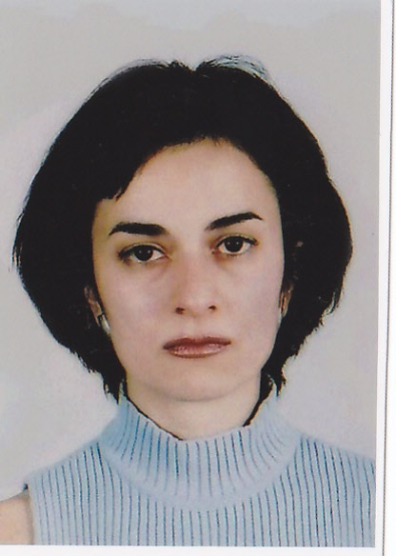

Research interest: hydrology, hydrochemistry, quality of the river water, physical geography

Background:
Education:
2011- 2013 - Bulgarian Academy of Sciences- NIGGG, PhD in quality of the river water

2005- 2007 - University of Sofia - St. “Kl. Ohridski”, Bulgaria, qualification - European public administration, level- master

2002- 2004 - University of Sofia – St. “Kl. Ohridski”, Bulgaria, qualification – Geography –
“Hydrology and Climatology”, level- master

1998/99- 2001/02 - University of Sofia – St. “Kl. Ohridski”, Bulgaria, qualification - Geographer, teacher of geography, level- bachelor

1993- 1998 - High school for Maths and Natural sciences- Acad. “L.Chakalov” – Sofia

Professional experience:

10/2009- 09/2010 - Bulgarian Academy of Sciences, Institute of Geography- position: Geographer
12/2007- 06/2009 - “HUAWEI TECHNOLOGIES BULGARIA” LTD, position: assistant- engineering department
07/ 2004- 11/2007 - National Student House- Ministry of education, HR Department, position: assistant – coordinator
02/2003- 06/2003 - High school “K.Timiriazev”, Sofia, position: teacher of Geography

Recent projects (last 5 years):

Formation of Highly Qualified Young Researchers in Information Technologies for Optimization, Pattern Recognition and Decision Support Systems. Contract with the Ministry of Education, Youth and Science: BG051PO001-3.3.04/40/28.08.2009, leader: Assoc. Prof., PhD Dyliana Stefanova, term - 28.08.2009 - 28.08.2011, position- PhD

“Spatial analysis and evaluate quality of river water by hydrochemical and hydrobiological indicators”, leader: Assoc. Prof.,PhD Marian Varbanov, term - 01.06.2010 - 31.05.2013, position- specialist

Selected Publications (last 5 years):
1. Gartsiyanova, K. CHANGES OF THE RIVER WATER CHEMICAL COMPOSITION AND WATER QUALITY IN UPLANDS OF THE CATCHMENT AREA OF RIVER VIT AND RIVER OSAM - In : proceedings from international conference “Development of economy and society based on knowledge”. St. Zagora, 2009.

2. Gartsiyanova, K. NITROGENOUS POLLUTION IN RIVER VIT AND RIVER OSAM - In : proceedings from international conference “Geography and regional development”. S., NIGGG-BAS, 2010, pp.503-513.

3. Gartsiyanova, K. Organic pollution in river Vit and river Osam. – Problems of Geography, 2011, 3-4, pp. ( in press).

