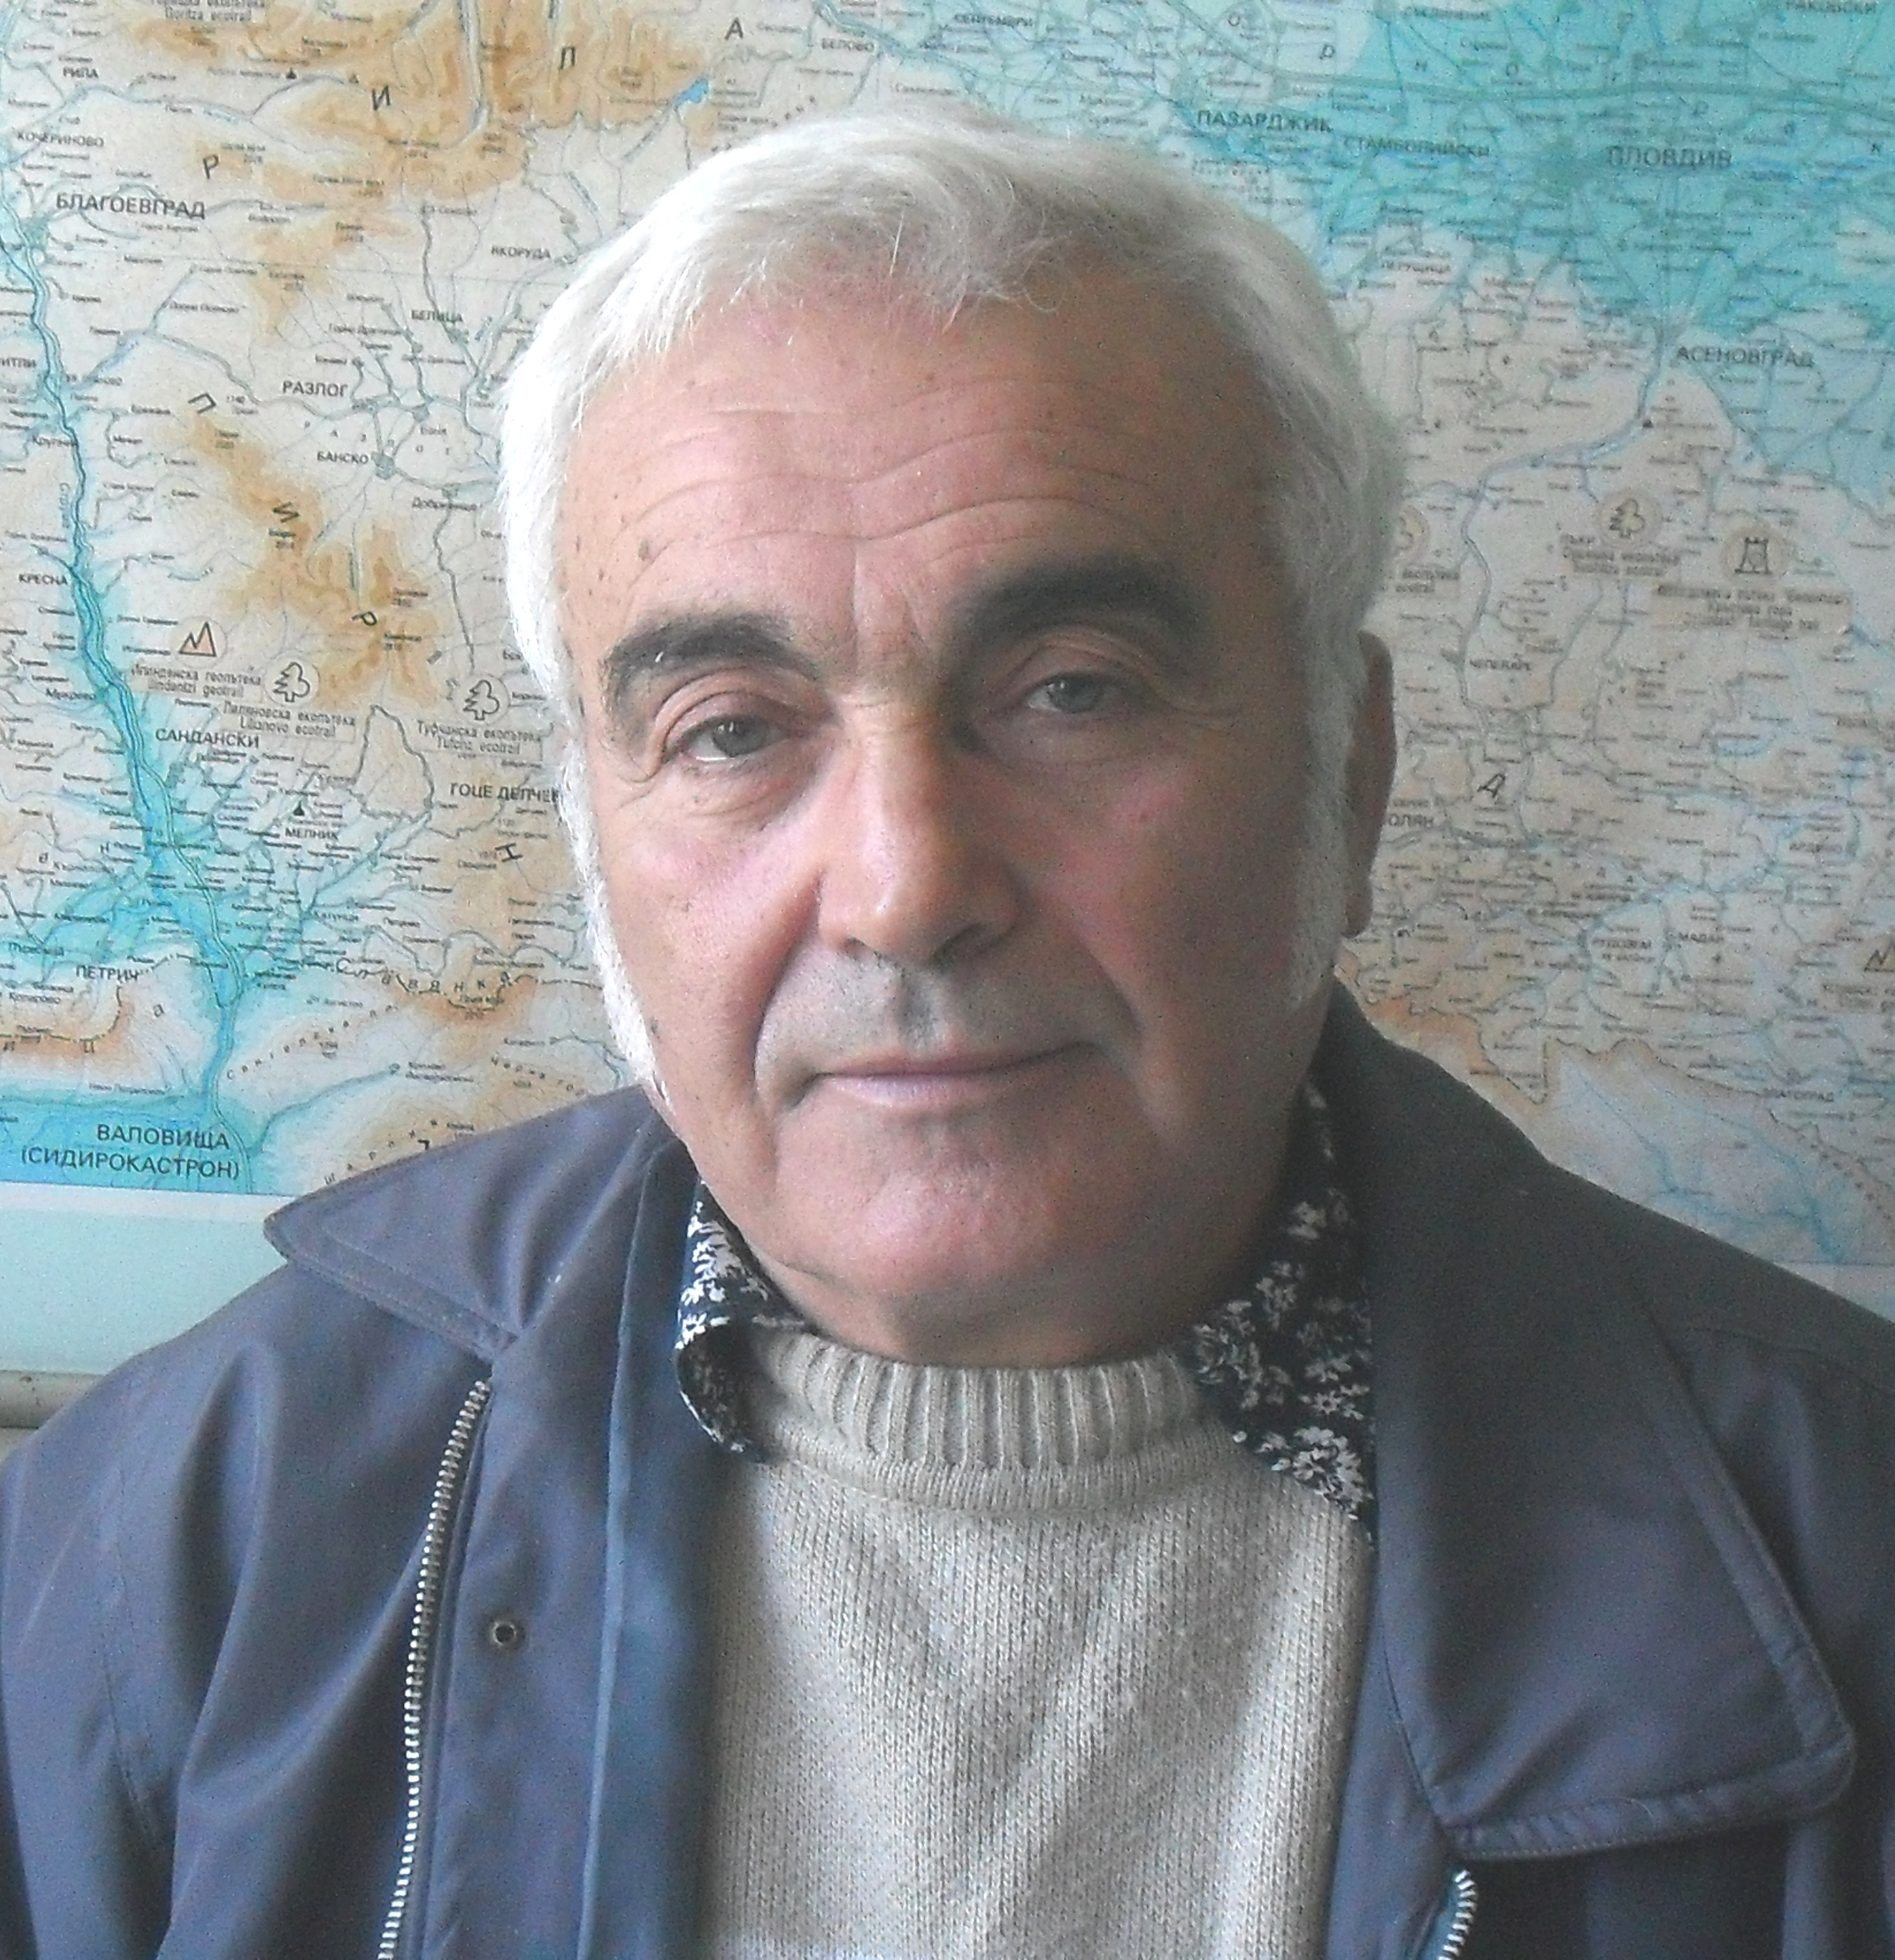 | Assoc. Prof. Peter Petrov, PhD  Tel.: +359 2 971 34 85  Е-mail: baret.org@gmail.com  Research interests (key words):  Landscape ecology, sustainable development, regional science, tourism, strategic planning, karstology.  Education:  1981 – PhD (code 01.08.01 – physical geography) – Institute of Geography – Bulgarian Academy of Sciences (BAS)  1971 – MA (hydroklimatology) - Sofia University “St. Kliment Ohridski”, Faculty of Geography and Geology  Professional experience:  2010 – National Institute of Geophysics, Geodesy and Geography (NIGGG) – Bulgarian Academy of Sciences (BAS) – associate professor  1981 - 2010 Institute of Geography – Bulgarian Academy of Sciences (BAS) - research associate, senior research associate.  Recent projects (last 5 years):  Comparative characteristics of lake Crknica and lake Srebarna from the point of view of ecosystem services, in association with Ljubljana University, Slovenia, Project leader, 2009-2010  The natural and cultural heritage of Bulgaria – a basis for formation of local, regional and national tourism, Project leader, 2005-2010.  PART – RTI - Program for Accreditation of Rural Tourism “Train the Trainer” (LLP/LDV/PA/2009/IRL-CP607, Project leader: Cavan-Monaghan LEADER (Republic of Ireland), 2009 – 2011  Low-mountainous landscape park “Shiroka planina” – Prevala village, Chiprovtsi municipality, Project leader, 2010  Formation of forest-agricultural-touris zone (FATZ) “Gorna Ogosta – Goren Lom” - Chiprovtsi municipality, Georgi Damyanovo, Chuprene municipality and Berkovitsa municipality, Project leader, 2010  Landscape-historical park “Rachene” – village of Kameno Pole, Roman municipality, Vratsa district, Project leader, 2009  Formation of recreation-tourist zone “Visok” (Bulgaria – Serbia), Project leader, 2008  Landscape-historical park „Gradishte” – village of Dolno Dryanovo, Garmen municipality, Project leader, 2008  Botanic exposition complex “Sredna Mesta”, Hadzhidimovo municipality, Project leader, 2008  Karst landscape park „Ponora”, Vratsa municipality, Project leader, 2008  Selected Publications (last 5 years):  Petrov, P., N. Nikolov, 2010. Potential for non-traditional tourism in the North-Eastern High Rodopi Mountains, Problems of Geography 1-2/2010, pp. 121-130 (in Bulgarian)  Petrov, P., 2010. A different definition of some basic terms in tourism, Geography 21, 2/2010, pp. 3 – 8 (in Bulgarian)  Petrov, P., 2009. Trough combining of regional and integral approach towards more rational natural utilization in the limestone (karst) areas of Bulgaria – International Symposium “80 years of organized speleo- activity and speleology in Bulgaria”, 19-20 March, 2009 (in Bulgarian)  Petrov, P., 2008. Integral approach in the policy for development of rural areas – new planning aspects in rational nature utilization, In: Proceedings of national conference “The Bulgarian village between the romantic perception and the sober judgment” – Institute of Sociology – Bulgarian Academy of Sciences, Sofia, June 2008 (in Bulgarian)  Urushibara-Yoshino Kazuko, Petrov, P., 2008. Change of Sheep Transhumance in Bulgaria since Joining the EU.Buletin of the Faculty of Letters N 57, 2008, Hosei University, Tokyo, Japan, pp. 24-30  Petrov, P., 2008. A different perception of spatial systematization of the resources and the locations for ecotourism in Bulgaria, in connection with their rational utilization and conservation, Proceedings of the Science-applied conference “NATURA 2000 in the cross-border region Bulgaria-Romania – problems and perspectives”, Vratsa, 22-23 November 2008, pp. 105 - 126 (in Bulgarian)  Petrov, P., E. Gachev, G. Zhelezov, 2007. Landscape based land use planning in semimauntainous areas in the context of new economical conditions – following the example of Lukovit Municipality. – Volume of proceedings – International conference “Global problems”, Sofia University, 22 April 2007, pp. 391-396

