Rositsa Mikova
Tel.: (+3592) 979-6309
E-mail: rositzamikova@abv.bg

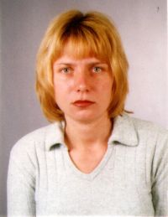

Research interest: Geography of Population and Settlements, migrations, urbanization.
Background:
Education:
PhD student in the specialty of Geography of Population and Settlements , Department of Geography, National Institute of Geophysics, Geodesy and Geography-BAS
Master’s degree in Geography, SU "St. Kliment Ohridski"
Bachelor’s degree in Automatation of Production, College of Energy and Electronics, TU-Sofia.

Professional experience: “Kremikovtzi”-AD, Reporter Foundation-data entry operator

Selected Publications (last 5 years):
Mikova, R. (2011) Intensity and Directions of the Inner Migrations in Bulgaria during the Period of Transition. – In: Jubilee National Scientific Conference with International Participation “The Man and the Universe”, Union of Scientists in Bulgaria-Smolyan, October 6-8, 2011 (in the press)
Working on the PhD thesis: “Migrations of Population in Bulgaria during the Transition Period "

